

The Windows File Explorer

A User-Based Documentation Guide

Prepared by Sean O'Connor for Code for Nepal



**Attribution-NonCommercial-ShareAlike  
CC BY-NC-SA**

Table of Contents

About This Guide 2

Definitions 2

Included Folders 3

The “Quick Access” Folder 3

The “This PC” Folder 3

The Documents Folder 4

The Downloads Folder 4

The Pictures Folder 4

The Videos Folder 4

The Music Folder 4

The OneDrive Folder 4

Opening the File Explorer 5

The Taskbar 5

The Search Bar 5

Navigation 6

Opening a File or Folder 6

The Navigation Buttons 6

The Back Button 6

The Forward Button 7

The Dropdown Arrow 7

The Up Arrow 7

The Navigation Pane 7

The Address Bar 8

The Search Bar 9

# About This Guide

All screen captures in this guide are taken from a non-activated version of Windows 10 Home, version 2004, run on a virtual machine. This guide should be accurate for all versions of Windows 10, and most of the functionality demonstrated should also be available on the Windows 7 file explorer.

This is not a complete guide to the Windows file explorer, but this will show some of the most efficient ways to navigate your file system using the Windows file explorer.

This guide aims to improve your digital literacy in the areas of Curation, Creation, and Scholarship. Efficiently traversing your file system will allow you to spend less time finding and organizing your files and more time creating, teaching, learning, or doing whatever else you may desire!

# Definitions

* File: any type of document, image, video, etc. stored on your system.
* Folder: essentially a file that contains other files. Works similarly to a folder in real life: files can be stored in these folders, and even other folders can be stored in folders. Folders can also contain “shortcuts” that will take you to a folder or open a file that is not in the current folder.
  + Subfolder: a folder stored within a folder.
  + Containing folder: the folder that contains the current folder. For example, the containing folder for the Pictures folder is the “This PC” folder.
* File System: the system of folders and files in your computer’s storage.
* Taskbar: the colored bar at the bottom of the screen in Windows 10. The Taskbar contains the Start menu, the Search Bar, and several icons that open applications, among other things.
* Search Bar: the text field on the left side of the taskbar. This can be used to search for any file, folder, application, or setting on your system. If a file or folder is found, it can be opened in the File Explorer.

Any other technical terms will be defined when used.

# Included Folders

These folders are very commonly used, so they are included by default in Windows 10.

## The “Quick Access” Folder

When opening the File Explorer from the taskbar or the search bar, this is the folder that will be shown. This folder contains shortcuts to the system’s most frequently used folders. It also includes links to recently opened files. See figure 1 below:

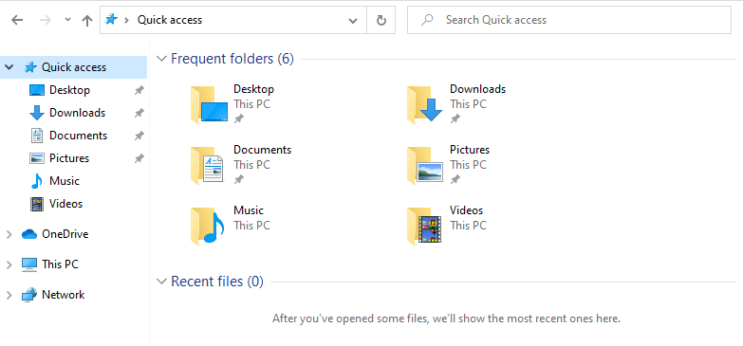

Figure 1: The "Quick Access" folder.

## The “This PC” Folder

This folder contains links to several other important folders, including the Documents, Downloads, Music, Pictures, and Videos folders. It also includes links to the computer’s individual drives. See figure 2 below:

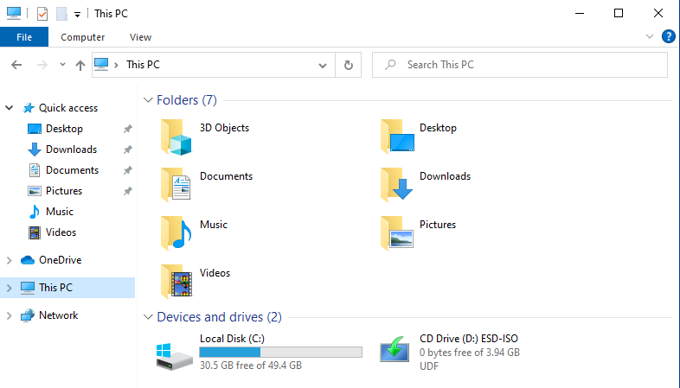

Figure 2: The "This PC" folder.

## The Documents Folder

This folder is generally used for storing Word Documents, PowerPoints, PDFs, and many other types of Documents. They are typically organized into subfolders so that files can be found and searched for more easily.

## The Downloads Folder

This folder typically stores all files downloaded from the internet. These could be any normal type of file, or even installers for different applications. These files may be copied to other folders, but a copy is typically kept here.

Note: Sometimes, when opening or downloading a file that you have already downloaded, the file will be downloaded again with a number appended to the file name. This can clutter the Downloads folder and waste storage space. To resolve this, either find the file you are looking for in the Downloads folder to avoid downloading it again, or periodically look for duplicates in your downloads folder and delete them.

## The Pictures Folder

This folder is meant for storing image files. These can be screenshots, pictures, or other images.

## The Videos Folder

This folder is meant for storing video files. They are sometimes subdivided into screen recordings, webcam recordings, or other categories by the applications that create them.

## The Music Folder

This folder is meant for storing any music files. This folder is the first one searched by any music players such as Windows Media Player or Groove Music when they search for music to play.

## The OneDrive Folder

The OneDrive folder is special: It backs up several of the included folders to Microsoft’s servers. This means that files stored in this folder can be accessed online, or even on other computers that are signed into your Microsoft account. It also means that if your current machine breaks or you lose access to it, your files can be restored to another machine.

Note: These features require a stable internet connection and a Microsoft account.

# Opening the File Explorer

There are many ways to open the Windows file explorer. Aside from the ways demonstrated here, other applications such as Microsoft Office products and even web browsers frequently open the file explorer so that the user can select a document to open or upload.

## The Taskbar

Windows typically places a shortcut to the file explorer on the taskbar by default. The icon resembles a manilla folder. See figure 3 below:



Figure 3: A snippet of the taskbar. The File Explorer icon is outlined in red.

Clicking this icon will open the file explorer.

## The Search Bar

If the File Explorer icon is not on the taskbar, the search bar offers another way to open the file explorer without navigating back to the desktop.

Type the words “File Explorer” into the search bar, and it will show up as the top search result. Clicking on the result in the left menu, clicking the “Open” option, or pressing the enter key will open the file explorer. See figure 4 below:

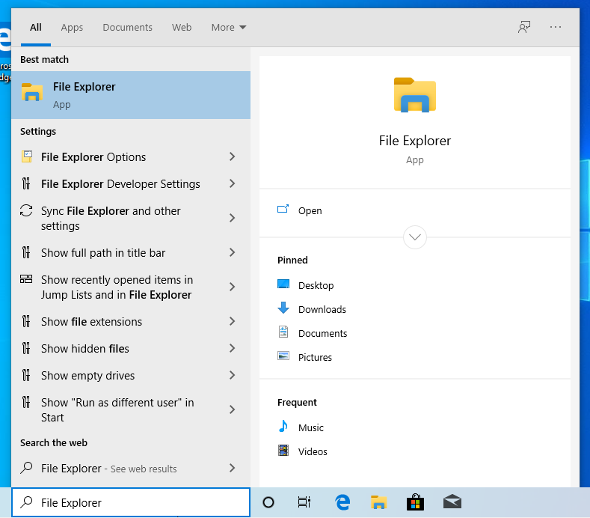

Figure 4: Typing "File Explorer" into the taskbar. The File Explorer shows up as the top result.

# Navigation

This section will cover techniques for navigating through folders and files in the file explorer.

## Opening a File or Folder

To open a file or folder, either double click on it (click twice rapidly) or right click on it and click the “Open” option. See figure 5 below:

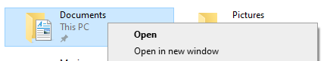

Figure 5: The right click menu, shown when the Documents folder is right clicked. The “Open” option is outlined in red.

When a file is opened, it is handled by a separate application that knows how to open the file. When a folder is opened, the file explorer navigates to this folder and displays what is inside of it.

## The Navigation Buttons

At the top left of the file explorer, there are 4 buttons. See figure 6 below:

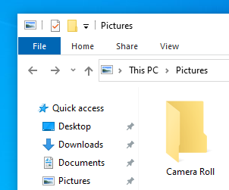

Figure 6: The top left of the file explorer. The navigation buttons are outlined in red.

### The Back Button

The first button is the back button. See figure 7 below:



Figure 7: The back button, outlined in red.

The back button navigates to the previous folder. For example, if the Documents folder is navigated to from the “Quick Access” folder, clicking the back button will navigate back to the “Quick Access” folder.

### The Forward Button

The next button is the forward button. See figure 8 below:



Figure 8: The forward button, outlined in red.

The forward button does the opposite; it goes “forward.” For example, once the back button is used to return to the “Quick Access” folder from the documents folder, the forward button can be used to return to the Documents folder.

### The Dropdown Arrow

The next button is the dropdown arrow. See figure 9 below:



Figure 9: The dropdown arrow, outlined in red.

The dropdown arrow can be used to see all the folders that can be navigated back or forward to. In the situation described above, the dropdown arrow would show the Documents and “Quick Access” folder when clicked. This button is useful for going back or forward multiple times, as it can save several clicks.

Note: The Forward and Dropdown arrow buttons can only be used after the back button has been used.

### The Up Arrow

The final button is the up arrow. See figure 10 below:



Figure 10: The up arrow, outlined in red.

The up arrow navigates “up” and out of the current folder into the containing folder (see definitions). For example, clicking the up arrow while in the Documents folder will navigate to the “This PC” folder regardless of how the documents folder was navigated to. This is because the Documents folder is inside of the “This PC” folder.

Note: the back arrow and up arrow behave slightly differently. The back button navigates to the folder you were previously at regardless of where you are currently are in the file system, while the up arrow always navigates to the containing folder.

## The Navigation Pane

On the left side of the file explorer, there is a small window displaying several included folders. These folders and their subfolders can be navigated to at any time by clicking on them. See figure 11 below:

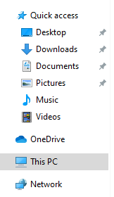

Figure 11: The Navigation pane. Located on the left side of the file explorer below the navigation buttons.

## The Address Bar

Located to the right of the navigation buttons. This bar shows the path the system takes to get to this folder. Clicking any of these folders will navigate to that folder. See figure 12 below:

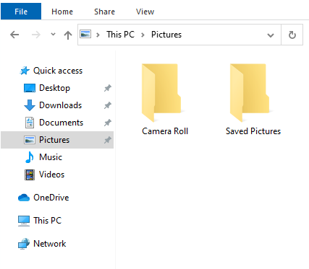

Figure 12: The Address bar, outlined in red.

Clicking anywhere to the right of the last folder will display the file path in text form. This can then be modified or copied, as shown below in figure 13:



Figure 13: The address of the current folder highlighted.

To the right of these folders, there is a refresh button. This button reloads this folder similarly to the way that web browsers refresh pages. If the files in this folder were changed by another application, refreshing the File Explorer will display these changes.

There is also a dropdown arrow in the search bar. This displays the file paths of recently accessed files or folders.

## The Search Bar

To the right of the navigation bar is the search bar. This search bar searches the inside of the current folder for files or folders that match the text typed into it. See figure 14 below:

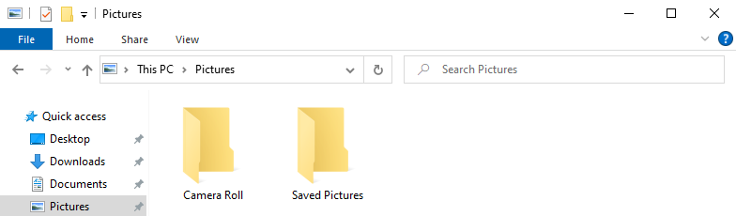

Figure 14: The search bar, outlined in red.

Note: Searching for anything in a large folder can take a very long time. Therefore, if you know which folder a file may be in, it is better to search that folder than a large containing folder such as “This PC” folder. For example, if a file is in the Documents folder, it is better to search in the Documents folder than the “This PC” folder.